**EFFECTS OF ENERGY PRODUCTION AND CONSUMPTION ON AIR POLLUTION IN SERBIA**

**Marija Živković**

University of Belgrade-Faculty of Mining and Geology, Serbia, marija.zivkovic@rgf.bg.ac.rs

***Abstract:*** *Energy production and combustion, mostly from unregulated or inefficient fuel combustion, are the single most important anthropogenic sources of air pollutant emissions. Energy sector in Serbia is highly fossil fuel intensive: 87.88% of energy consumed in Serbia is related to fossil fuels, while almost 95% of energy sources are combusted. In 2017. energy related carbon dioxide emission in Serbia is was 47.95 million tones. The main source of carbon dioxide emission was coal, responsible for almost 70% of energy related carbon dioxide emission in the country. Currently the transport sector is the main source of pollution in urban areas in Serbia, while the main sources of air pollution are: biomass (firewood) for carbon monoxide and NOx from the buildings sector and oil derivates for carbon monoxide and NOx from the transport sector.*

***Key words****: energy related emissions, Serbia*

**1.INTRODUCTION**

Energy is essential to economic and social development of each community and improved quality of life of citizens. Energy demand in the world has a constant growth, which is driven by increased number of inhabitants and growth of life standard [1]. Much of the world's energy is currently produced and consumed in ways that could not be considered as sustainable [2]. Primary energy consumption in the world is characterized with a constant growth and the dominant share of fossil fuels of 79.7% [3]. The renewable energy source with the highest share is biomass with 6%. Fossil fuels and biomass make more than 85% of the primary energy need to be transformed to heat and/or electricity through combustion processes [3], which are the main sources of atmospheric pollution [4]. The need to control atmospheric emissions of greenhouse and other gases and substances leads to the necessity of improving efficiency in energy production, transmission, distribution and consumption in the at the global level, or level of the country, region etc [4].

Nowadays the most of attention of is dedicated to reduction of carbon dioxide emission and mitigation of climate changes [5], while other pollutants receive less attention. Energy production and combustion, mostly from unregulated or inefficient fuel combustion, are the single most important anthropogenic sources of air pollutant emissions. It is estimated that 85% of particulate matter and almost all of the sulfur oxides and nitrogen oxides are consequences of combustion processes [4]. These pollutants are responsible for the most of negative impacts of air pollution, directly or after they are transformed into other pollutants in the atmosphere. Around 6.5 million deaths are attributed each year to poor air quality, making this the world’s fourth-largest threat to human health, behind high blood pressure, dietary risks and smoking [4].

Poverty and fossil fuel-intensive development and urbanization are determined as the main causes of air pollution [4]. Emissions can be quantified at the level of total primary energy consumption, transformation or final energy consumption, while the special interest is dedicated to emissions related to electricity and heat generation, as well as from the transport and buildings sectors [6]. The transport sector is a major source of air pollutants, despite the many policy and technology advances achieved so far. It is responsible for around half of all energy related nitrogen oxide emissions and is an important source of primary particulate matter. The buildings sector also receives attention since it is responsible for the highest shares of particulate matter and carbon dioxide at a global level (Figure 1) [4].Thus, cities could become pollution hotspots, as they concentrate people and related energy consumption.

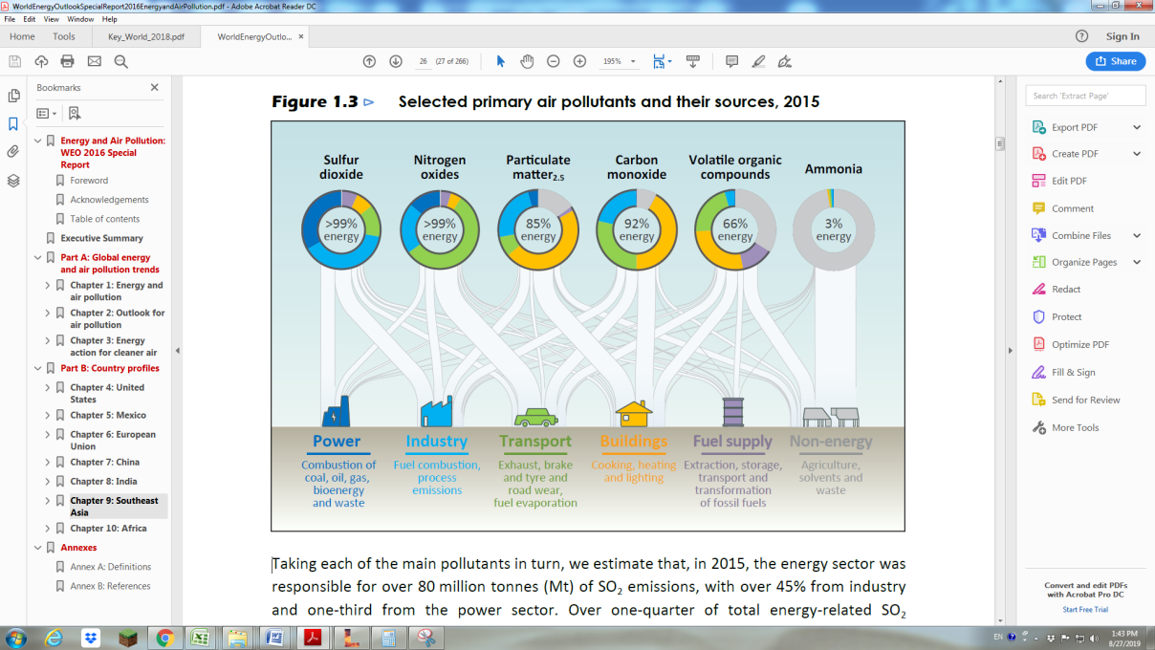

Figure 1. Selected primary air pollutants and their sources (Energy and air pollution)

This paper is aimed to determine energy related emissions in Serbia, with attention given to energy consumption in the buildings and the transport sectors, since they are seen as the main sources of air pollution in urban areas due to a great number of uncontrolled or poorly controlled combustion processes.

**2.ENERGY CONSUMPTION AND PRODUCTION IN SERBIA**

Data on energy consumption: by fuel and by activity are the bases for determination of pollutants emissions. For the case of Serbia data can be found in energy balances of the country [7]. The trend and the structure of primary energy consumption for the last ten years are given in Figure 2. In 2017 total primary energy supply was 667890 TJ [8]. It can be characterized as highly fossil intensive – 87.88% of energy consumed in Serbia is related to fossil fuels. Almost 50% of total energy consumed in the country is related to coal -the dominant energy source in the energy sector of Serbia. Figure 2b shows that almost 95% of energy sources are combusted either for electricity and/or heat generation or in final energy consumption with end consumers [8].



1. b)

Figure 2 a) total primary energy consumption for period 2007-2017

b) structure of total primary energy consumption in 2017

Coal is mainly used for electricity generation i.e. 88% of total coal energy is utilized in thermal power plants or CHPs. Structure of electricity generation by source is presented in Figure 3. In average about ¾ of electricity in Serbia is generated in TPPs, with average efficiency of 34.2% [8].



Figure 3. Electricity generation by source

Final energy consumption in Serbia in 2017 was 365047 TJ [8], with structure divided according to sectors and energy products presented in the Figures 4.1.a and 4.1.b.



1. b)

Figure 4. Final energy consumption a) by sector b) by fuel

Households and public and commercial sector (the buildings sector) account 44.45% of final energy consumption, so they need to receive special attention in terms of pollutant emissions. Industry is responsible for 27.62% of final energy consumption, followed with the transport sector with 25.73%. From figure 4b can be seen that 63.63% of final energy is combusted with end consumers. Only consumption in industry can be considered as a controlled and regulated. The rest is taking place in internal combustion engines or stoves and furnaces.

**3. ENERGY RELATED EMISSIONS**

Based on the data presented in [8] and default values for carbon dioxide emission factors [9] annual energy related carbon dioxide emission in Serbia is determined. In 2017 it was 47.95 million tones. The main source of carbon dioxide emission is coal, responsible for almost 70% of energy related carbon dioxide emission in the country (Figure 5). It is the energy source with the highest share and it is the carbon most intensive fuel, with the highest carbon dioxide emission factor. The structure of coal combustion indicates that about 60% of annual carbon dioxide emission in is a consequence of electricity generation in TPPs. Bearing in mind low efficiency of plants and the feeding fuel-lignite, in average 1kg of carbon dioxide is emitted during production of 1kWh of electricity in TPPs.



Figure 5. Carbon dioxide emission by fuel

Table 1. Selected indicators of energy consumption and emission [10]

|  |  |  |  |  |
| --- | --- | --- | --- | --- |
| Country | TPES/pop (toe/capita) | TPES/GDP (toe/1000$) | CO2/pop  (tCO2)/capita | CO2/TPES  (tCO2/toe) |
| Serbia | 2.16 | 0.37 | 6.46 | 2.98 |
| Bulgaria | 2.55 | 0.32 | 5.68 | 2.23 |
| Croatia | 2.03 | 0.14 | 3.80 | 1.87 |
| Germany | 3.77 | 0.09 | 8.88 | 2.36 |
| Poland | 2.58 | 0.10 | 7.63 | 2.95 |

Data about carbon dioxide emission can be analyzed and discussed when they are transformed to indicators and considered in wider context (Table 1) [10]. Among presented countries Serbia has the highest value of TPES/GDP which indicates the highest energy consumption per unit of produced value and energy intensive industry. In the case of Germany the highest value of emission per capita indicates higher energy consumption per capita, but with higher efficiency of economy. The highest value of indicator CO2/TPES for Serbia indicates the most carbon intensive energy mix.

Emission of other pollutants in Serbia is determined for the buildings and transport sector, since urban areas are now recognized as black points of air pollution. Estimation of pollutants emission is more demanding comparing with determination of carbon dioxide emission. Besides fuels composition values of emission factors are strongly driven by the nature of combustion processes (excess air coefficient, level of mixing fuel and oxidizer, local combustion temperature, etc). This means that there is no single level of emissions per unit of a specific fuel (emission factor) but, rather, a range of emission factors depending on such variables [4]. Specific fuels play a key role in relation to certain types of air pollution, both in terms of emissions per unit of fuel consumed and in terms of their share of total emissions (Figure 6).

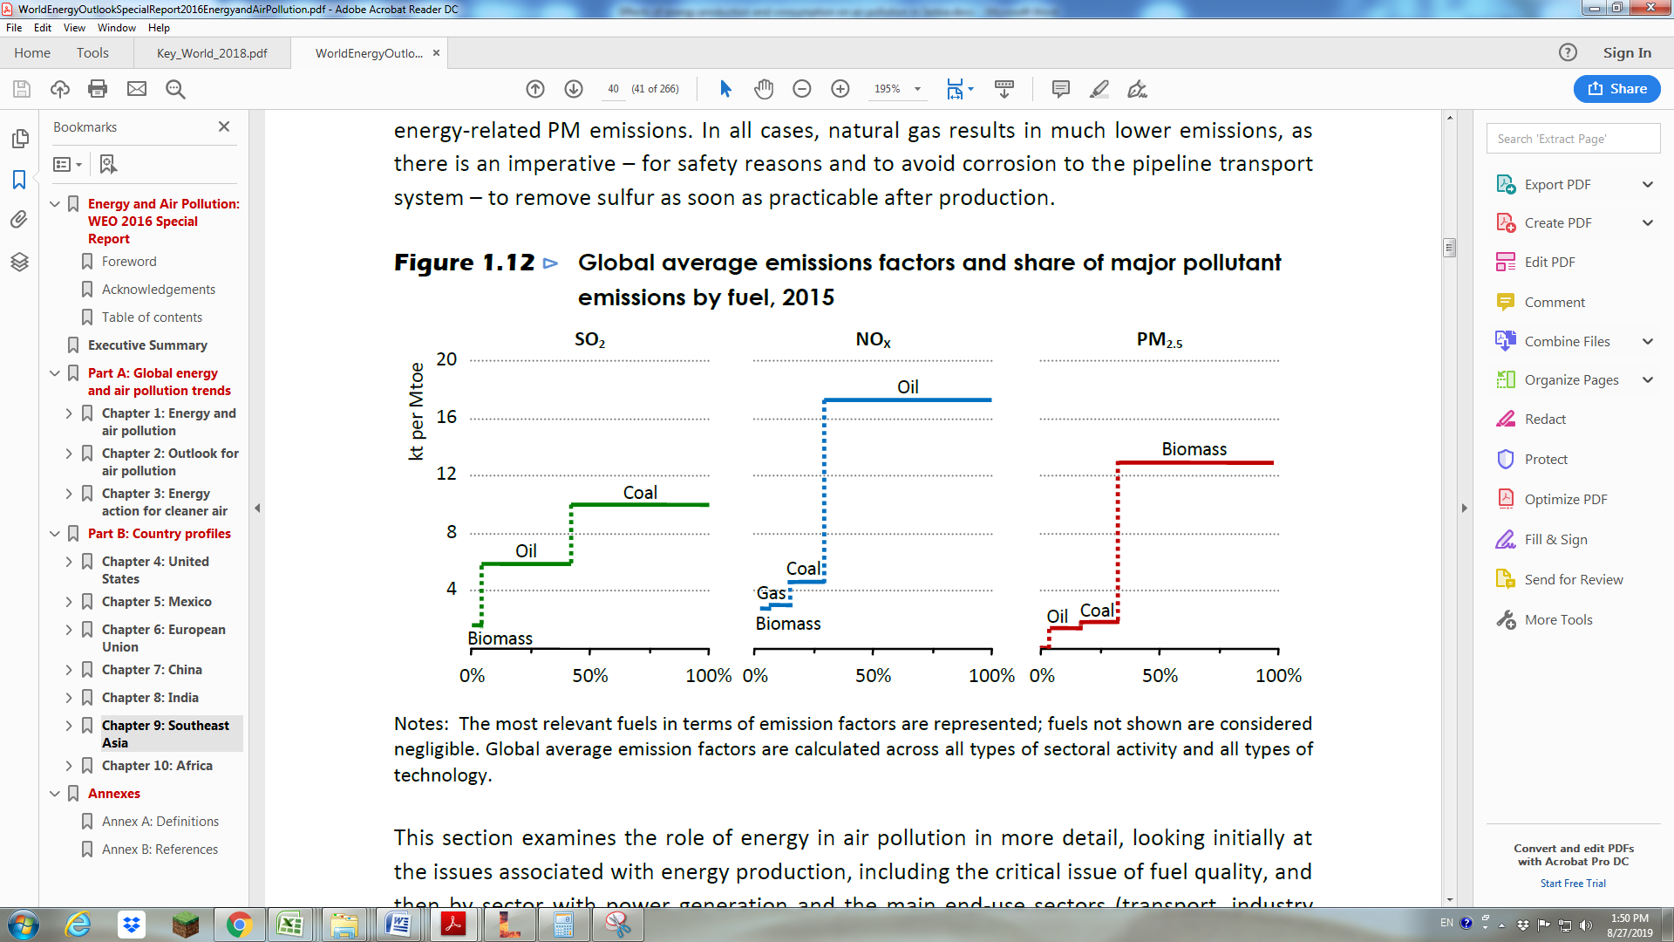

Figure 6.Global average emission factors [4]

Emission factors can vary widely for each fuel among end-use sectors, depending on the technology implemented. For example: a gasoline car with a catalytic converter can emit 1.4 kt of NOX per Mtoe, while a diesel truck without filters can emit more than 50 kt of NOX per Mtoe [4].

By applying appropriate emission factors for the combination fuel and activity, emission of carbon monoxide in Serbia from the buildings and transport sectors in 2017. is estimated to 560.3 thousand tones with a structure by fuel given in figure 7.



1. b)

Figure 7. Carbon monoxide emission a) by fuel and b) by sector

Main source of carbon monoxide emission from the transport sector is passenger transport (303.4 million of tones) while the emission from the residential sector is related to space heating (206 million of tones) (Figure 8)



Figure 8. Sources of carbon monoxide emission in the transport and residential sectors by activity

Nitrogen oxides emission from the buildings and transport sectors in 2017.was 63.1 million tones (Figure 9). The dominant source of NOx emission in Serbia is transport sector due to specific conditions of combustion in internal combustion engines: high temperature and sub stoichiometric equivalence ratio.



Figure 9.Nitrogen oxides emission a) by fuel and b) by sector

Presented results indicate that currently the transport sector is the main source of pollution in urban areas in Serbia, while the main sources of air pollution are: biomass (firewood) for carbon monoxide and NOx from the buildings sector and oil derivates for carbon monoxide and NOx from the transport sector.

**4. DISCUSSION**

Actions directed to reduction of emissions can be divided into two main groups: to avoid and to reduce. From the research presented in this paper it is clear that reduction of pollutants need to tackle coal consumption in terms of carbon dioxide emission and firewood and oil derivates in terms of carbon monoxide and nitrogen oxides. Actions should sublimate both types of actions: avoid and reduce

Effect or some measures that could be option for mitigating air pollution in Serbia are explored in [11].Emissions from the buildings are mainly due to the space heating. Related emissions can be reduced by energy rehabilitation of buildings, connection to district heating systems, introduction of more efficient heating options –heat pumps, etc. In [11] is found that the highest energy savings and highest impact to the energy efficiency and emissions in building sector could be achieved by energy rehabilitation of buildings.

Actions that could be undertaken in the transport sector are: introduction of more efficient vehicles, modal shift, driving behavior, car sharing, introduction of electric vehicles. It is found that the highest energy savings and reduction of emissions could be achieved by modal shift focusing on the rail transport mode.

**5. CONCLUSION**

Energy sector in Serbia is highly fossil fuel intensive: 87.88% of energy consumed in Serbia is related to fossil fuels, while almost 95% of energy sources are combusted. In 2017. energy related carbon dioxide emission in Serbia is was 47.95 million tones. The main source of carbon dioxide emission was coal, responsible for almost 70% of energy related carbon dioxide emission in the country. Further analyses indicate that about 60% of annual carbon dioxide emission in is a consequence of electricity generation in TPPs.

Nitrogen oxides emission from the buildings and transport sectors in 2017.was 63.1 million tones, while emission of carbon monoxide was 560.3 thousand tones. Main source of carbon monoxide emission from the transport sector is passenger transport (303.4 million of tones) while the emission from the residential sector is related to space heating (206 million of tones). The dominant source of NOx emission in Serbia is transport sector due to specific conditions of combustion in internal combustion engines: high temperature and sub stoichiometric equivalence ratio.

Obtained results indicate that currently the transport sector is the main source of pollution in urban areas in Serbia, while the main sources of air pollution are: biomass (firewood) for carbon monoxide and NOx from the buildings sector and oil derivates for carbon monoxide and NOx from the transport sector. Reduction of emission can be achieved by implementation of measures aimed to avoid and reduce emissions. For the buildings sector energy rehabilitation of buildings, connection to district heating systems, introduction of more efficient heating options –heat pumps are some of foreseen measures, while in the case of the transport proposed measures are introduction of more efficient vehicles, modal shift, driving behavior, car sharing, introduction of electric vehicles and biofuels.

**REFERENCES**

1. Nenad Đajić, Energija za održivisvet,Rudarsko-geološkifakultet, Beograd, 2002, ISBN 86-7352-081-9
2. K. Bilen, O. Ozyurt, K. Bakır, S.Karsl, S.Erdogan, M.Yılmaz, O.Comakl, Energy production, consumption, and environmental pollution for sustainable development: A case study in Turkey, Renewable and Sustainable Energy Reviews, Volume 12, Issue 6, August 2008, Pages 1529-1561
3. International Energy Agency, Key World Energy Statistics 2018, available at:<https://webstore.iea.org/key-world-energy-statistics-2018> (accessed 28.8.2019.)
4. International Energy Agency, Energy and air pollution, available at: <https://www.iea.org/publications/freepublications/publication/WorldEnergyOutlookSpecialReport2016EnergyandAirPollution.pdf> (accessed 28.8.2019.)
5. Larry E. Erickson, Reducing greenhouse gas emissions and improving air quality: Two global challenges, Environ Prog Sustain Energy. 2017 Jul; 36(4): 982–988
6. World Health Organization, <https://www.who.int/sustainable-development/transport/health-risks/air-pollution/en/> (accessed 28.8.2019.)
7. Statistical office of the Republic of Serbia, Energy balances for years 2007-2017, available at: <http://www.stat.gov.rs/sr-latn/oblasti/energetika/> (accessed 28.8.2019.)
8. Statistical office of the Republic of Serbia, Energy balances 2017, available at: <http://publikacije.stat.gov.rs/G2019/Pdf/G20195645.pdf> (accessed 28.8.2019.)
9. Intergovernmental panel on climate change, 2006 IPCC Guidelines for National Greenhouse Gas Inventories, Volume 2, Energy, available at: <https://www.ipcc-nggip.iges.or.jp/public/2006gl/vol2.html> (accessed 28.8.2019.)
10. IEA, Key World Energy Statistics 2018, available at <https://webstore.iea.org/key-world-energy-statistics-2018>
11. Horizon 2020 project, HERON Forward-looking socio-economic research1 on Energy Efficiency in EU countries Contract no: 649690 Deliverable D.4.1